**“ALCOHOL SENSING AND AUTOMATIC ENGINE LOCKING**

**SYSTEM WITH LOCATION SHARING”**

Submitted in partial fulfilment of the requirements for the partial completion of

**MINI PROJECT II [19EC5PWMP2]**

IN

**ELECTRONICS AND COMMUNICATION ENGINEERING**



**VISVESVARAYA TECHNOLOGICAL UNIVERSITY, BELGAUM**

SUBMITTED BY:

**Nitheeshkumar H V 1BM19EC098**

**Nitesh R 1BM19EC099**

**Padmaj U Naik 1BM19EC101**

**Pavan Kumar M 1BM19EC102**

Under the Guidance of

**Mrs Monika Sharma D**

(Assistant Professor, ECE, BMSCE)



Department of Electronics and Communication Engineering

**B.M.S COLLEGE OF ENGINEERING**

(Autonomous College Affiliated to Visvesvaraya Technological University, Belgaum)

Bull Temple Road, Basavanagudi, Bangalore-560019

**DECLARATION**

We undersigned students of fifth semester B.E in ECE, B.M.S College of Engineering, Bangalore, hereby declare that the dissertation entitled “ALCOHOL SENSING AND AUTOMATIC ENGINE LOCKING SYSTEM WITH LOCATION SHARING”, embodies the report of my project work carried out independently by us under the guidance of Mrs Monika Sharma D Assistant Professor, ECE Department, BMSCE, Bangalore in partial fulfilment for the award of Bachelor of Engineering in Electronics and Communication Engineering from Visvesvaraya Technological University, Belgaum during the academic year 2021-2022.

We also declare that to the best of our knowledge and belief, this project has not been submitted for the award of any other degree on an earlier occasion by any student.

Place: Bengaluru

Date: 09/03/2022

**Nitheeshkumar H V 1BM19EC098**

**Nitesh R 1BM19EC099**

**Padmaj U Naik 1BM19EC101**

**Pavan Kumar M 1BM19EC102**

**B.M.S COLLEGE OF ENGINEERING**

(Autonomous College under VTU)

**Department of Electronics and Communication Engineering**



**CERTIFICATE**

This is to certify that the project entitled **“ALCOHOL SENSING AND AUTOMATIC ENGINE LOCKING SYSTEM WITH LOCATION SHARING”** is a bonafide work carried out by **Niteeshkumar H V** (USN:1BM19EC098), **Nitesh R** (USN:1BM19EC099), **Padmaj U Naik** (USN:1BM19EC101) and **Pavan Kumar M** (USN:1BM19EC102) in partial fulfilment for the partial completion of PROJECT FOR COMMUNITY SERVICE [19EC5PWMP2] during the academic year 2021-2022.

**Mrs. Monika Sharma D Dr. Siddapaji Dr. S. Muralidhara**

Prof., ECE, BMSCE HOD, ECE, BMSCE Principal, BMSCE

**External Examination:**  **Signature with date**

1.

2.

**ABSTRACT**

The main purpose behind this project is “DRUNK DRIVING DETECTION”. Now a day’s many accidents happening because of the alcohol consumption of the driver or the person who is driving the car. The drunk driving is a major reason of accident in almost all countries all over the world. Alcohol detection in car project is designed for the safety of the people seating inside the car. This project should be installed inside the vehicle. In this project we have developed an automatic engine locking system. The input for the system is alcoholic breath.

The controller waits for the output from alcohol sensor. Here a stimulating process activated using a dc motor through the freewheeling diode & complete process is under the supervision of an intelligent Atmega 328microcontroller. Even through efficient set up requirements have been adopted for the traditional methods, where in this process this could be a better idea of interesting the complete state of the art design into the system. Most of traditional systems are likely to be more dependent on the operator & it may fail due to various factors like battery life, power consumption as well as the unavoidable external disturbances. Thus, drunk driving is a major reason of accidents in almost all countries all over the world. Alcohol detector in car project is designed for the safety of the people seating inside the car. If there are many traces of alcohol above the set limit then the engine will be locked by the system and at the same time the buzzer will on so, that we can avoids accidents.

**ACKNOWLEDGEMENT**

Any achievement, be it scholastic or otherwise does not depend solely on the individual efforts but on the guidance, encouragement and cooperation of intellectuals, elders and friends. A number of personalities, in their own capacities have helped us in carrying out this project work. We would like to take this opportunity to thank them all.

We express profound gratitude to respected principal **Dr. S. Muralidhara,** BMS College of Engineering for providing a congenial environment to work in. Our sincere gratitude to

**Dr. Siddappaji,** Professor, Head of the Department, Electronics and Communication Engineering and our guide for this Project for encouraging and providing this opportunity to carry out the project in the department and who helped us in all the ways to carry out the project work. He stood beside and guided us in every step.

We would like to thank our guide **Mrs. Monika Sharma D,** Assistant Professor, Department of ECE who helped us in all the ways to carry out the project work. She stood beside and guided us in every step.

We thank all our professors for providing the basic knowledge without which this project wouldn't have been possible. Last but not the least we thank our family and friends, who made their valuable support compelled us to maintain a standard throughout our endeavour.

Niteeshkumar H V

Nitesh R

Padmaj U Naik

Pavan Kumar M

**CONTENTS**

**TOPIC PAGE NO**

**Chapter 1: Introduction**

* 1. Introduction 1
  2. Problem Definition 3
  3. Problem Solution 4

**Chapter 2: Literature Survey** 5

**Chapter 3: Methodology and Implementation**

3.1 Block Diagram 7

3.2 Project Flow 9

3.3 Hardware Architecture

3.3.1 Circuit Diagram 10

3.3.2 Component Description 11

3.4 Software Architecture

3.4.1 Software Requirement 16

3.4.2 Program

**Chapter 4: Results and Discussion**

4.1 Applications and Advantages 17

**Chapter 5: Conclusion and Future Work**

5.1 Conclusion 18

5.2 Future Scope

**Acknowledgment and References** 20

**CHAPTER 1. INTRODUCTION**

* 1. **Introduction**

We hear lot of accidents due to drunk driving and it will not be in stable condition. So rash driving is the in convenience for another road death for the drunk driver and not for others.

The enormity of this problem transcends race or boundary. In India, the problem is being tackled by issuing laws prohibiting the act of drivers getting drunk before or while driving as well as delegating law enforcements agents to arrest and punish the culprits. However, effective monitoring of drunken drivers is a challenge to the policemen and road safety officers. This limited ability of law enforcement agents undermines every manual effort aimed at curbing drink-driving.

Ministry of Statistics and Programme Implementation reported 11,363 road accidents in 2016. Although the report stated speed violation as the foremost cause of these accidents, it can safely be inferred that most of the cases would have been due to driver’s unstable condition caused by drivers getting drunk before they drive. The investigation done by the World Health Organization in 2008 shows that about 50%-60% of traffic accidents are related to drink-driving. More so, WHO data on road traffic deaths revealed 1.25 million traffic deaths were recorded globally. Data collected showed that 67.2% of commercial vehicles drivers in India admitted to drinking alcohol during working days. This shows that most drivers, especially commercial and heavy-duty trucks drivers engage in drink-driving, which can lead to accident. India sets a legal limit of 30 g/100mL Blood Alcohol Concentration (BAC), any level above that is said to be illegal.

The BAC depicts the quantity of alcohol in a certain volume of blood. It is measured as either gram of ethanol per decilitre of blood (g/dl, commonly used in the United States), or milligram per litre of blood, (mg/l, used in much of Indian Subcontinent). For BAC level from 0.4 to 0.6, drivers feel dazed/confused or otherwise disoriented, and it is generally not safe for a driver to drive a vehicle under such condition. Also, BAC level for 0.7 to 0.8 makes a driver’s mental, physical and sensory functions to be severely impaired. At this stage, a driver is inactive and incapable of driving. BAC level of 0.2 to 0.3 is still not safe but the driver still has a little degree of self-control.

Every day, about 28 people in the United States die in drunk-driving crashes — that's one person every 52 minutes. A total of Rs 10.49 crore was collected from the drunken drivers in the form of fines. Overall, 278 persons lost their lives in road accidents during the year of which 18 deaths were due to drunken driving,

The National Crime Records Bureau (NCRB) data also shows that around 2% of the total road accidents that happen in India are due to drunk driving. In 2019 alone, around 3,000 people lost their lives in road accidents

that were related to drunk driving, while 6,675 people were left injured in such drunk driving related road accidents

In order to deal with this problem we propose the solution. In this system uses a compact arduino uno board. Programs are developed in embedded C Our project is based on prevention of drunk & driving. So in our project we use a MQ3 sensor, a DC motor, An Arduino board & a LCD display. Here Arduino is used for the programming and interfacing purpose; LCD display is used to show the percentage of the alcohol present in alcoholic breath of the person, MQ3 sensor is used to detect the alcohol molecules.

This sensor is placed on the steering of the car. When a driver tries to drive the car in over drunken condition, the MQ3 sensor senses the presence of alcohol and when the percentage level is above the stated value a signal will be send to Arduino. According to that signal the engine will stop working. In this project we have set the percentage level of alcohol to 40%.

* 1. **Problem Definition**

Alcohol has a very significant effect on the functions of the body which are vital to driving and being able to function. Alcohol is a depressant, which mainly affects the function of the brain. Alcohol first affects the most vital components of the brain and "when the brain cortex is released from its functions of integrating and control, processes related to judgment and behavior occur in a disorganized fashion and the proper operation of behavioural tasks becomes disrupted." Alcohol weakens a variety of skills that are necessary to perform everyday tasks.

One of the main effects of alcohol is severely impairing a person's ability to shift attention from one thing to another, "without significantly impairing sensory motor functions." . People that are intoxicated also have a much more narrow area of usable vision than people who are sober. The information the brain receives from the eyes "becomes disrupted if eyes must be turned to the side to detect stimuli, or if eyes must be moved quickly from one point to another.

This thought process and brain function that is lost under the influence of alcohol is a very key element in regards to being able to drive safely, including "making judgments in terms of traveling through intersections or changing lanes when driving."[]](https://en.wikipedia.org/wiki/Drunk_driving#cite_note-ReferenceC-2) These essential driving skills are lost while a person is under the influence of alcohol.

A correlation has been found between lack of conscientiousness and accidents, meaning that "low conscientiousness drivers were more often involved in driving accidents than other drivers." When tested the drivers scored very high in the areas of "depression, vulnerability (to stress), [gregariousness](https://en.wikipedia.org/wiki/Gregariousness), modesty, tender mindedness", but significantly lower in the areas of "ideas (intellectual curiosity), competence, achievement striving and self-discipline." The sample also tested considerably higher than the norm in "[somatization](https://en.wikipedia.org/wiki/Somatization), [obsessions](https://en.wikipedia.org/wiki/Obsessions)-[compulsions](https://en.wikipedia.org/wiki/Compulsions), interpersonal sensitivity, depression, anxiety, hostility, phobic anxiety, [paranoia](https://en.wikipedia.org/wiki/Paranoia), [psychoticism](https://en.wikipedia.org/wiki/Psychoticism)", especially in the area of depression. This area "includes intellectual curiosity, receptivity to the inner world of fantasy and imagination, appreciation of art and beauty, openness to inner emotions, values, and active experiences." In all these various factors, there is only one which indicates relapses for driving under the influence: depression causing road accidents and a serious threat to other passengers and pedestrians.

* 1. **Problem Solution**

In order to avoid the accidents and the atrocities caused by drunk drivers in the society .We have come up with a technique of “ALCOHOL SENSING AND AUTOMATIC ENGINE LOCKING SYSTEM WITH LOCATION SHARING “.

The best way to deal with it is by not letting the drunkard to drive their vehicles . so the system we built works for the above principle, initially when the alcoholic intoxicated person sits in the car the alcohol concentration is measured by the sensor and automatically locks the engine not letting the driver to start the car . When the measured levels are relatively very high the person’s location will be shared to the family to take over the situation .

This solution is implemented using a MQ3 alcohol sensor which is capable of determining the alcohol concentration via the person’s breathe in the car **,** the controller waits for the output from alcohol sensor. Here a stimulating process activated using a dc motor through the freewheeling diode & complete process is under the supervision of an intelligent Atmega 328 microcontroller. Even through efficient set up requirements have been adopted for the traditional methods, where in this process this could be a better idea of interesting the complete state of the art design into the system.

Most of traditional systems are likely to be more dependent on the operator & it may fail due to various factors like battery life, power consumption as well as the unavoidable external disturbances. Alcohol detector in car project is designed for the safety of the people seating inside the car. If there are many traces of alcohol above the set limit then the engine will be locked by the system and at the same time the buzzer will on so, that we can avoid accidents.

**CHAPTER 2: LITERATURE SURVEY**

There are many works carried out on the drivers drowsiness detected. A large number of road accidents takes place due to the fatigue of drivers due to alcohol consumption. An embedded system with UNO and open CV is developed. Where the Alcoholic drivers are detected in real time using the drivers drowsiness and intoxication, since large number of road accidents takes place due to alcohol drinking .

In the a computer vision concept is used which has an alcohol gas sensors combined with the Raspberry pi micro-controller and embedded systems

An ARM based face recognition system is developed with open CV library using the ARM based micro-controller and USB camera to detect continuous image . The image captured is compared with the existing database and the output is sent to the GPS and sent the information regarding the person to the authorises incharge using GSM The drivers vigilance level is monitored and alerts the driver for about the abnormal driving.

It also detects the drivers drowsiness based on the Viola jones algorithm by analysing the faces and eyes. The algorithm is embedded in Raspberry Pi and integrated with the video camera and Computer vision open library. The eye ball movement are tacked using the camera and that is taken as the input. The face recognition steps uses the face detected and select the area of analysis using the pixel of each coordinate.

The number of white of pixels are compared with the between the coordinates for recognition. From this recognition it identity the drivers fatigue .Raspberry pi is used in unmanned aerial vehicles used for disaster areas. The done are used in anomaly detection in atmosphere temperature. The drones are provided with the ability to land if the temperature is beyond the threshold value.

The temperature is measured using the monitor attached to it .The Vehicle Engine Lock System for Alcohol Detection P. Ranjana, Rajeswari Mukesh, Achhint Kumar, N.N.S.S.Sujith, C.H.Sathyasai VEHICLE ENGINE LOCK SYSTEM FOR ALCOHOL DETECTION 364 Published By: Blue Eyes Intelligence Engineering & Sciences Publication Retrieval Number: E10760275S419/19©BEIESP intentional accidents has become more in recent years due to the development of new in-vehicle technology. The drivers scenario like eye blink are collected and drivers were dictated on how to drive through their mobile phones.

It analyses the behaviour of the driver and classifies it and avoids the accidents through the metric obtained. An ardiuno based embedded system is designed for a more safe and secure journey . They used a vehicle based control in the school zone and controls the speed of the vehicle in brides, hospital areas and many other important areas . Though there are many works carried out they concentre only on a specific feature and the accuracy level should be improved.

This technique which utilizes GPS and GSM to ascertain alcohol but this technique is very expensive, but the expenses can be cut off to a great extent. In this project a buzzer is being used which is highly economical, and can keep people in close proximity vigilant.

Composite health monitoring and sensors based on infrared are utilized to ascertain alcohol as but the chance of false alarm can't be avoided in this system, because minute change in some situations can result in false alarm but in our project use of required technology makes it more authentic.

To prevent the mishap of drunken driving older projects have used PIC16F877A microcontroller which is an outdated system and expensive one also which restrains its use to only certain class of society whereas we are using Arduino and Uno microcontroller which is advanced as well as economical.

Worrying about the drunken driving the previous publications suggests the system to overcome the issue but using mQ2 alcohol sensor has come flames .MQ2 alcohol sensor is not authentic and raises the chance of false alarm while we have used MQ3 which is highly authentic.

To cope with alcohol detection simultaneous the publications have proposed a system which is very complicated and use of P89V57RD2 microcontroller makes it highly expensive also this system can only be equipped with 2 wheelers whereas , Ardiuno uno microcontroller is economical as well as can be equipped with any class of vehicle making it more authentic and successful.

**CHAPTER 3: METHODOLOGY AND IMPLEMENTATION**

**3.1 Block Diagram**

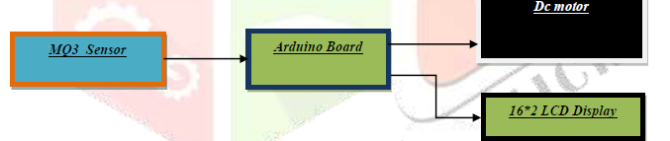

**Fig 1: Block Diagram**

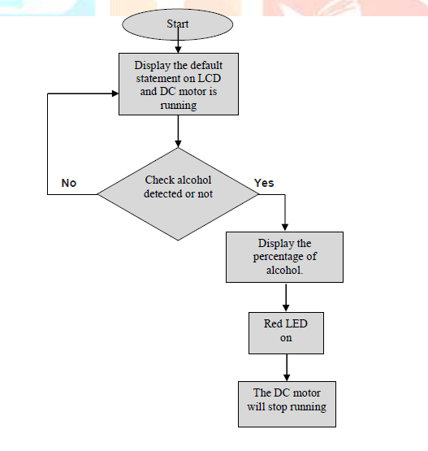

**Fig 2: Flow Chart of Working**

The Alcohol Detection with Engine Locking system helps to reduce accidents which are occurring due to drunk driving. MQ-3 sensor detects the presence of alcohol in the surroundings. The sensor provides output on the basis of the concentration of the alcohol, if the alcohol concentration is higher the conductivity of MQ3 sensor increases which in turn gives the reading to ARDUINO.

If the reading is greater than the threshold level, ARDUINO will stop the DC motor. The red LED will also blink . Now, with the help of SIM900A the message will be sent to the family or the civil forces that the particular vehicle is unsafe and can be a threat to other people , normally dc motor is in running condition at that instance of time green led glows & the % of alcohol is less than 40. But when the % of alcohol goes beyond 40, then the motor will stop and red led glows.

We use Ethyl alcohol to demonstrate our project. In this project the MQ3 sensor is used as an alcohol sensor. It senses the % of ethanol molecule. When the % of ethanol will increase above the stated value, then it gives a signal to Arduino.

The detected analogue voltage values are read by the microcontroller; the Arduino Uno board contains 8 channels, 10-bit device that changes an analogue voltage on a pin to a digital number. The system will link input voltages from 0-5V with values from 0-1023V to generate 5Vs for every 1024 units. The system will process the analogue signal and convert it to digital value of 0 or 1. Also, the analogue values from the alcohol sensor will be scaled to percentage, and this percentage is equivalent to the analogue voltage values in ppm (part per million).

The first condition is the intoxication stage; the second condition is the slightly drunk stage and the last stage is drunkenness stage. Each stage will be a condition to perform a task based on the level of alcohol. In the intoxication stage, the LED indicator will be activated only, the alarm will be OFF and the car engine will be ON. In stage two, the alarm and the green LED indicator will be ON, as well as the car engine. Finally, the driver is mentally and physically inactive in stage three, so the engine will be OFF while the alarm and red LED will be ON. Therefore, once the system detect alcohol in stage three the car will be stopped and the driver can park by the roadside.

**3.2 Project Flow**

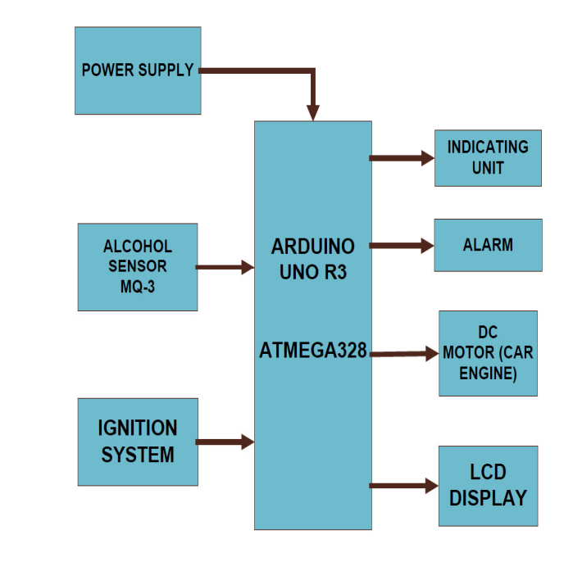

**These are some more goals of this framework:**

1. When driver is starting the car then the alcohol sensor begins detecting at the condition where vehicle speed is equivalent to zero.

2. If alcoholic driver is recognized then the ignition system will turn off and notification will be shown on LCD with alarm/buzzer.

3. A flag is set when first condition is passed without discovery of liquor.

4. If alcohol is recognized for this situation at that point signal is sent to the fuel blocker by Arduino for locking the start system. So, the driver feel's that vehicle is going to stop and after that he will place the car at proper location.

**3.3 HARDWARE ARCHITECTURE**

**3.3.1 Circuit Diagram**



**Fig 3: Circuit Diagram**

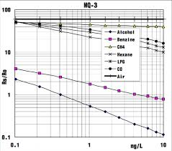

**Fig 4: Behaviour of MQ3 sensor**

**3.3.2 Component Description:**

**HARDWARE REQUIREMENTS**

* Power Supply
* Arduino UNO
* MQ3 Alcohol Sensor
* DC motors
* Buzzer
* Relay
* GSM-GPS Module
* Breadboard
* Jumper Wires
* Battery

**HARDWARE DESCRIPTION**

**Arduino UNO board:**

It is an open-source electronic platform based on easy-to-use hardware and software. It is used for sending receiving and processing the signal and it helps to rotate the servo motor and shows the display on the screen.

Features:

* Microcontroller ATmega328
* Operating Voltage 5V
* Input Voltage 7-12V(Recommended)
* Input Voltage (limits) 6-20V
* Digital I/O Pins 14 (of which 6 provide PWM output)
* Analog Input Pins 6
* DC Current per I/O Pin 40 mA
* DC Current for 3.3V Pin 50 mA
* Flash Memory 32 KB (ATmega328)
* SRAM 2 KB (ATmega328)
* EEPROM 1 KB (ATmega328)
* Clock Speed 16 MHz



**Figure 4: Arduino UNO**

**DC Motor:**

DC or direct current motor works on the principal, when a current carrying conductor is placed in a magnetic field; it experiences a torque and has a tendency to move. This is known as motoring action. If the direction of current in the wire is reversed, the direction of rotation also reverses. When magnetic field and electric field interact, they produce a mechanical force, and based on that the working principle of DC motor is established. In our project DC motor is using as engine starter which would be connected to crank of the engine. The speed of a dc motor is directly proportional to the supply voltage, so if we reduce the supply voltage, the motor will at half speed. The speed controller work by varying the average voltage sent to the motor. This voltage is depending upon the alcohol sensor (mq3). That means when the alcohol sensor sensed the alcohol percentage less than 40%, the motor will run. But if the sensor sensed the alcohol percentage above 40%, the motor will stop.



**Figure 5: DC Motor**

**Buzzer/Alarm:**

A buzzer is a mechanical, electromechanical, magnetic, electromagnetic, electro-acoustic or piezoelectric audio signalling device. A piezo electric buzzer can be driven by an oscillating electronic circuit or other audio signal source. A click, beep or ring can indicate that a button has been pressed. A conventional Piezo bell works between 3 – 12 volts DC.



**Figure 6: Buzzer**

**MQ3 Sensor:**

The Analog Gas Sensor-Mq3 Is Suitable for Alcohol Detecting the Sensor Can be used as a Breath Analyzer. It Has a High Sensitivity to Alcohol & Small Sensitivity to Benzene. The Alcohol Module Is Used to Sense the Alcohol. The Analog Output of Which Is Applied to The Arduino Board. Resistance Value of Mq3 Is Different Components.



**Figure 7: MQ3 Alcohol Sensor**

**Relay:**

The relay module is **an electrically operated switch that can be turned on or off deciding to let current flow through or not**. They are designed to be controlled with low voltages like 3.3V like the ESP32, ESP8266, etc

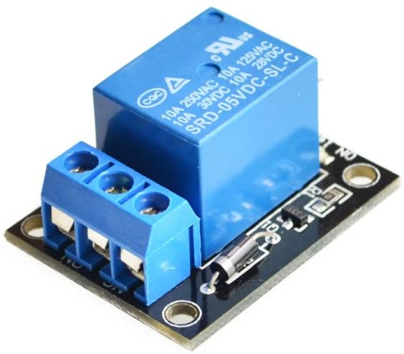

**Figure 8: Relay Module**

**Battery Source:**

To provide Energy for motor to perform battery is a very important component.

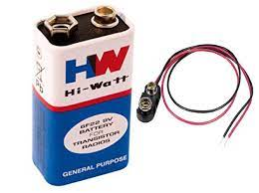

**GSM-GPS Module:**

GSM is a standard set developed by the European Telecommunications Standards Institute (ETSI) to describe technologies for second-generation ([2G](https://www.electronicsforu.com/market-verticals/communication/2g-vs-3g-basics-mobile-communication)) digital cellular networks. A GSM modem is a specialised type of modem that accepts a SIM card and operates over a subscription to a mobile operator just like a mobile phone. GSM modems are a cost-effective solution for receiving SMS messages because the sender is paying for the message delivery. To perform these tasks, a GSM modem must support an extended AT command set for sending and receiving SMS messages, as defined in the ETSI GSM 07.05 and 3GPP TS 27.005 specifications. It should also be noted that not all phones support this modem interface for sending and receiving SMS messages, particularly most smartphones like the Blackberry, iPhone and Windows mobile devices.

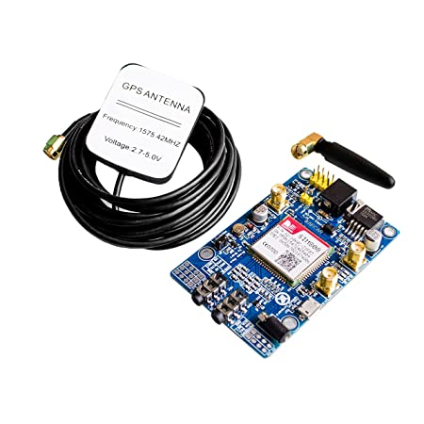

**Figure 9: GSM-GPS Module**

**Jumper Wires:**

A jumper wire (also known as jumper, jumper wire, jumper cable, DuPont wire, or DuPont cable – named for one manufacturer of them) is an electrical wire or group of them in a cable with a connector or pin at each end (or sometimes without them simply "tinned"), which is normally used to interconnect the components of a breadboard or other prototype or test circuit, internally or with other equipment or components, without soldering.



**Figure 10: Jumper Wires for Connection**

**3.4 Software Architecture:**

**3.4.1 SOFTWARE REQUIREMENTS**

* Arduino IDE
* Embedded C Programming

**3.4.2 Program:**

#define sensor_pin 7

#define Buzzer 9

#define LED 13

int motor=4;

int sensor_value;

void setup() {

Serial.begin(115200);

pinMode(motor,OUTPUT);

Serial.println("MQ3 warming up!");

delay(120000);

}

void loop() {

sensor_value = digitalRead(sensor_pin);

Serial.print("Digital Output: ");

Serial.print(sensor_value);

if (sensor_value) {

Serial.println(" | Alcohol: Not Detected");

digitalWrite(LED, LOW);

digitalWrite(motor,0);

noTone(Buzzer);

} else {

Serial.println(" | Alcohol: Detected!");

digitalWrite(LED, HIGH);

digitalWrite(motor,1);

tone(Buzzer, 1500);

delay(120000);

}

delay(2000

**CHAPTER 4: RESULTS AND DISCUSSIONS**

If alcoholic person tries command on vehicle the alcoholic sensor determines the existing of alcohol and shut down the vehicle engine and sound alarm by which the nearby people will exchange the seat. We can avoid any kind of loss of life by using this system. All equipment’s are totally tested and connected as required thereby giving us the much-needed result.

**4.1 Applications and advantages**

The applications of this project are easily visible.

• The Alcohol detection with engine locking system can be implemented in any

4- wheelers.

• The Alcohol detection with engine locking system can help prevent accidents due to

drunk driving.

• The Alcohol detection with engine locking system can be very helpful for police.

• The Alcohol detection with engine locking system prove automatic safety system for cars

and other vehicles.

**CHAPTER 5: CONCLUSION AND FUTURE WORK**

**5.1 Conclusion:**

An effective solution is provided to develop the intelligent system for vehicles which will monitor various parameters of vehicle in between constant time period and will send this data to the base unit as explained in this paper, by using hardware platform whose Core is Arduino, Alcohol sensor mq3. The whole Control system has the advantage of small volume and high reliability. Future scope of this system is to control the accidents and providing useful details about the accidental vehicle, thereby reducing the rate of accidents taking place due to drunken driving. This system brings innovation to the existing technology in the vehicles and also improves the safety features, hence proving to be an effective development in the automobile industry.

**5.2 Future Scope**:

We can implement Heart Rate Pulse Variability to find accurately & identify the driving

behaviour of drivers and to assist them by sending emergency alert to nearby Health care center.

**ACKNOWLEDGEMENT AND REFERENCES**

**Acknowledgement:**

As we present our project on “ALCOHOL SENSING AND AUTOMATIC ENGINE LOCKING SYSTEM”, we take this opportunity to offer our sincere thanks to all those without whose guidance this project might have remained a dream for us. We express our deepest gratitude to the Electronics & Communication Engineering Department whose ideas channelled our conscientious endeavours towards the project.

**REFERENCES:**

**[1]**Bhuta, Desai,Keni “Alcohol Detection and Vehicle Controlling” International Journal of Engineering Trends and Applications

(IJETA) – Volume 2 Issue 2, Mar-Apr 2015.

**[2]**. “Alcohol Detection and Accident Prevention of Vehicle ” ,IJIERE, Volume 2,Issue 3,2015.

**[3].** “Automatic Drunken Drive Prevention System”,IJSRTM, Volume2,March-April 2014, ISSN 2321-2543, pg. 74-77.

**[4].** M.H. Mohamad, MohdAminBin Hasanuddin, MohdHafizzie Bin Ramli, “Vehicle Accident Prevention System Embedded with Alcohol Detector”, International journal of review in electronics communication enigineering ( IJRECE), Volume 1, Issue 4 October 2013, e-ISSN:(2321-3159).

**[5].** http://howtomechatronics.com/projects/arduino-radar-project/